SC/Rep/2011/03
21September 2011

Report of the Meeting
Standing Committee on Economic Affairs
20-21 September 2011
Moscow, Russian Federation

1. The Standing Committee on Economic Affairs held its meeting on 20-21 July 2011 in Moscow, Russia. APA Delegations from Bahrain, Indonesia, Iran, Jordan, Kuwait, Pakistan, Russia, Syria, and Turkey participated in this meeting. The list of participants is attached as Annex I.

2. Honorable Mr. Evgeny Tugolukov, Chairman of the State Duma Committee on Natural Resources, Management and Environment delivered his welcoming remarks at the beginning of the meeting. He referred to the challenges facing Asian countries including the crisis of global economy and political turmoil surrounding a number of regions and emphasized on the critical role of Asian parliaments in dealing with these challenges in Asia. He also called for more cooperation among Member Parliaments.
H.E. Dr. Ali Khorram, APA Assistant Secretary-General, made an opening statement highlighting the importance of the issues under consideration by the Standing Committee for all Member Parliaments. He underlined the fact that holding four Sub-Committee meetings in the course of two days is a new experience for APA and if this new setting proved to be insufficient, we might need to hold these meetings in two countries, two meetings in each country.
3. The agenda of the meeting was then adopted. On the basis of APA usual practice, the Host Parliament was elected as the chair of the meeting. Honorable Mr. Evgeny Tugolukov chaired the meetings of the Sub-Committees on Environmental Issues, Global Warming, Climate Change and Planting Billions of Trees throughout Asia and Alleviating Poverty in Asia while Honorable Mr. Valery Yazev, Vice-Speaker of the State Duma and Chairman of the Standing Committee on Economic Affairs chaired the Sub-Committee meetings on Energy and Financial Crisis. Honorable Mr. Ahmed Al Mulla of Bahrain and Honorable Mr. Mohammad Jehangir Bader of Pakistan were elected as Vice-Chairmen and Honorable Mr. Mohammad Zohair Taghlibi of Syria was elected as the Rapporteur of the Committee.

4. The list of documents before the Meeting included:
i) SG/Rep/2011/03-2 of 3 September 2011, on Environment,
ii) APA/Res/2010/13 of 30 November 2010, on Environment,
iii) SG/Rep/2011/03-1 of 31 August 2011, on Poverty Alleviation,
iv) APA/Res/2010/14 of 30 November 2010, on Poverty Alleviation
v) SG/Rep/2011/3-4 of 21 September 2011 on Energy,
vi) APA/Res/2010/16 of 30 November 2010, on Energy,
vii) SG/Rep/2011/3-3 of 10 September 2011 on Financial Crisis,
viii) APA/Res/2010/15 of 30 November 2010 on Financial Crisis,

5. In the morning session of the 20 September 2011, the Sub-Committee meeting on Environment was convened. H.E. Dr. Majid Ravanchi, Assistant Secretary-General orally presented the report of the Secretary-General to the Sub-Committee. He highlighted the section of the report which included a number of measures suggested to Member Parliaments to take before the next round of negotiations during COP17 meeting to be held in Durban-South Africa late November 2011. He said that we should be prepared for this event and the parliamentarians need to be included in the delegations attending this conference.

6. The representatives of Bahrain, Indonesia, Thailand, Syria, Iran, Pakistan, Kuwait, Turkey and Russia participated in the General Debate. The participants welcomed the report of the Secretary-General to the Sub-Committee. They explained the measures their countries have taken to protect the environment at the national level. The role of parliamentarians in the policy-making concerning environmental issues and their oversight in the implementation process was emphasized. A number of participants underlined the need to put more emphasis on desertification.

7. Then, the Assistant Secretary-General introduced the draft resolution and following introduction of a number of amendments by some delegations, the draft resolution was adopted as SC/Economic/Res/2011/10 of 20 September 2011. The representative of Russia expressed his reservation concerning preamblular paragraph 10 of the draft resolution.

8. In the afternoon session of the 20 September 2011, the Sub-Committee meeting on Poverty Alleviation was convened. H.E. Dr. Majid Ravanchi, Assistant Secretary-General orally presented the report of the Secretary-General to the Sub-Committee. He highlighted the sections of the report which included references to last year's Summit on MDG at the United Nations as well as the role of urban informal sector in the fight against urban poverty and the role of parliaments in urban poverty alleviation.

9. The representatives of Syria, Bahrain, Russia, Kuwait, Thailand, Iran, Pakistan, Indonesia, Jordan and Turkey participated in the General Debate. The participants welcomed the report of the Secretary-General to the Sub-Committee. They explained the measures they have taken at the national and regional levels to assist the poor and alleviate poverty. They also supported the Millennium Development Goals as well as APA activities in the area of poverty alleviation.

10. Then, the Assistant Secretary-General introduced the draft resolution and following introduction of a number of amendments by some delegations, the draft resolution was adopted as SC/Economic/Res/2011/11 of 20 September 2011.

11. In the morning session of the 21 September 2011, the Sub-Committee meeting on Integrated Energy Market in Asia was convened. H.E. Dr. Ali Khorram, Assistant Secretary-General orally presented the report of the Secretary-General to the Sub-Committee. He discussed the Possibility of a Regional Energy Cooperation in Asia and highlighted the abundance of energy resources in West Asia and the high consumption of energy in East Asia. He raised some questions concerning the realization of the Integrated Energy Market in Asia. He also gave two models for peaceful nuclear energy cooperation among APA family.

12. The Member of Parliaments of Syria, Bahrain, Russia, Kuwait, Thailand, Iran, Pakistan, Indonesia, Jordan and Turkey participated in the General Debate. The participants discussed the peaceful nuclear energy cooperation among APA family, most in favor of such cooperation but Kuwait believed it was not advisable.

13. Afterwards, the Assistant Secretary-General introduced the draft resolution and following introduction of a number of amendments by some delegations, the draft resolution was adopted as SC/Economic/Res/2011/12 of 21 September 2011.

14. In the afternoon session of the 21 September 2011, the Sub-Committee meeting on Global Financial Crisis was convened. H.E. Dr. Ali Khorram, Assistant Secretary-General orally presented the report of the Secretary-General to the Sub-Committee. He warned about the new round of financial crisis in the European Union, the United States and Japan.

15. Different delegations commented and asked some questions about the new Global Financial Crisis which were answered by the Assistant Secretary-General.

16. After the break, H.E. Dr. Ali Khorram introduced the draft resolution and following introduction of a number of amendments by some delegations, the draft resolution was adopted as SC/Economic/Res/2011/13 of 21 September 2011.

17. Due to the shortage of time in each Sub-Committee for any deep and further discussion and deliberation, the Standing Committee on Economic Affairs supported the fact that holding four Sub-Committee meetings in the course of two days was insufficient therefore it recommended to hold these meetings in two countries, two meetings in two days in each country.

18. The Standing Committee expressed special appreciation to the State Duma of Russia for excellent organization of the meeting and the hospitality extended to all participants.

19. The Sub-Committee requested the attached draft resolutions to be forwarded to the first APA Executive Council meeting of 2011, to be recommended to the APA Plenary for consideration of the Economic Standing Committee.

Annex - 1
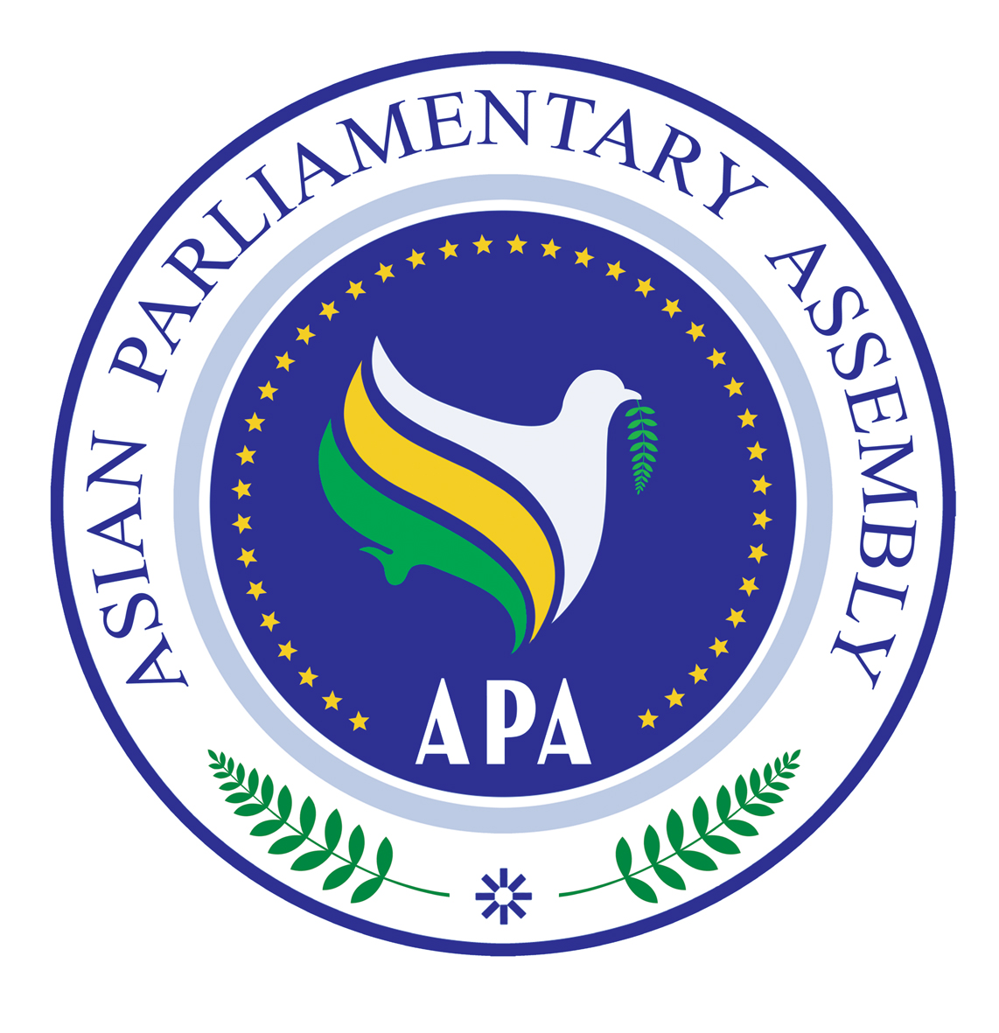
Asian Parliamentary Assembly
Standing Committee on Economic Affairs
Moscow, Russia
20-21 September 2011
AGENDA

- Welcoming address by Honorable Mr. Valery Yazev, Vice- Speaker of the State Dumas, APA Vice-President on Economic Standing Committee
- Opening remarks by Assistant Secretary-General of APA
- Adoption of the Agenda and Order of Business
- Election of Chairman, Vice-Chairmen
- Oral report of the Secretary General on Global Financial Crisis
- General Discussion
- Adoption of the final report of the Sub-Committee and consideration and recommendation for adoption of a possible draft resolution
- Oral report of the Secretary General on Environmental Issues, Global Warming, Climate Change in Asia
- General Discussion
- Adoption of the final report of the Sub-Committee and consideration and recommendation for adoption of a possible draft resolution
- Oral report of the Secretary General on Integrated Energy Market in Asia
- General Discussion
- Adoption of the final report of the Sub-Committee and consideration and recommendation for adoption of a possible draft resolution
- Oral report of the Secretary General on Poverty Alleviation
- General Discussion
- Adoption of the final report of the Sub-Committee and consideration and recommendation for adoption of a possible draft resolution
- Closing

Annex - 2 Lists of Participants
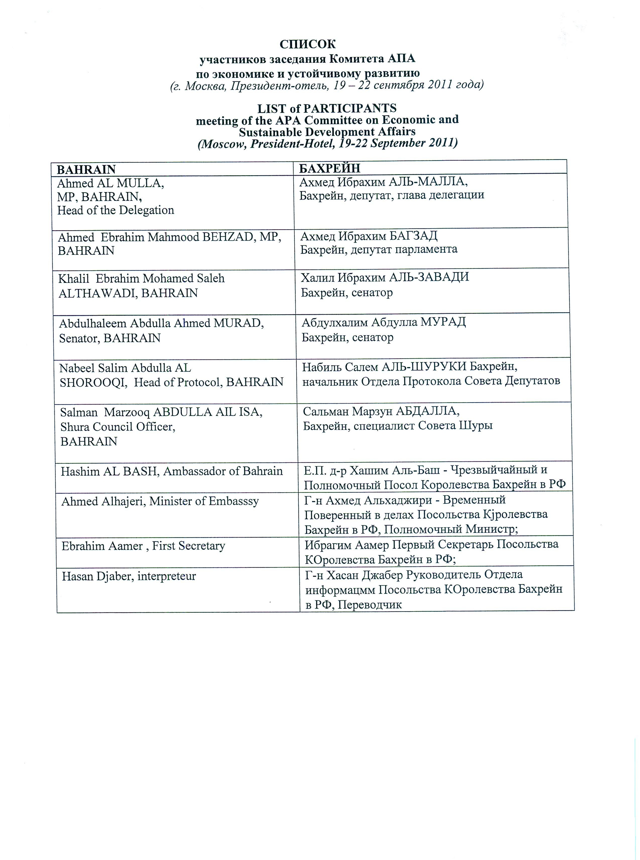
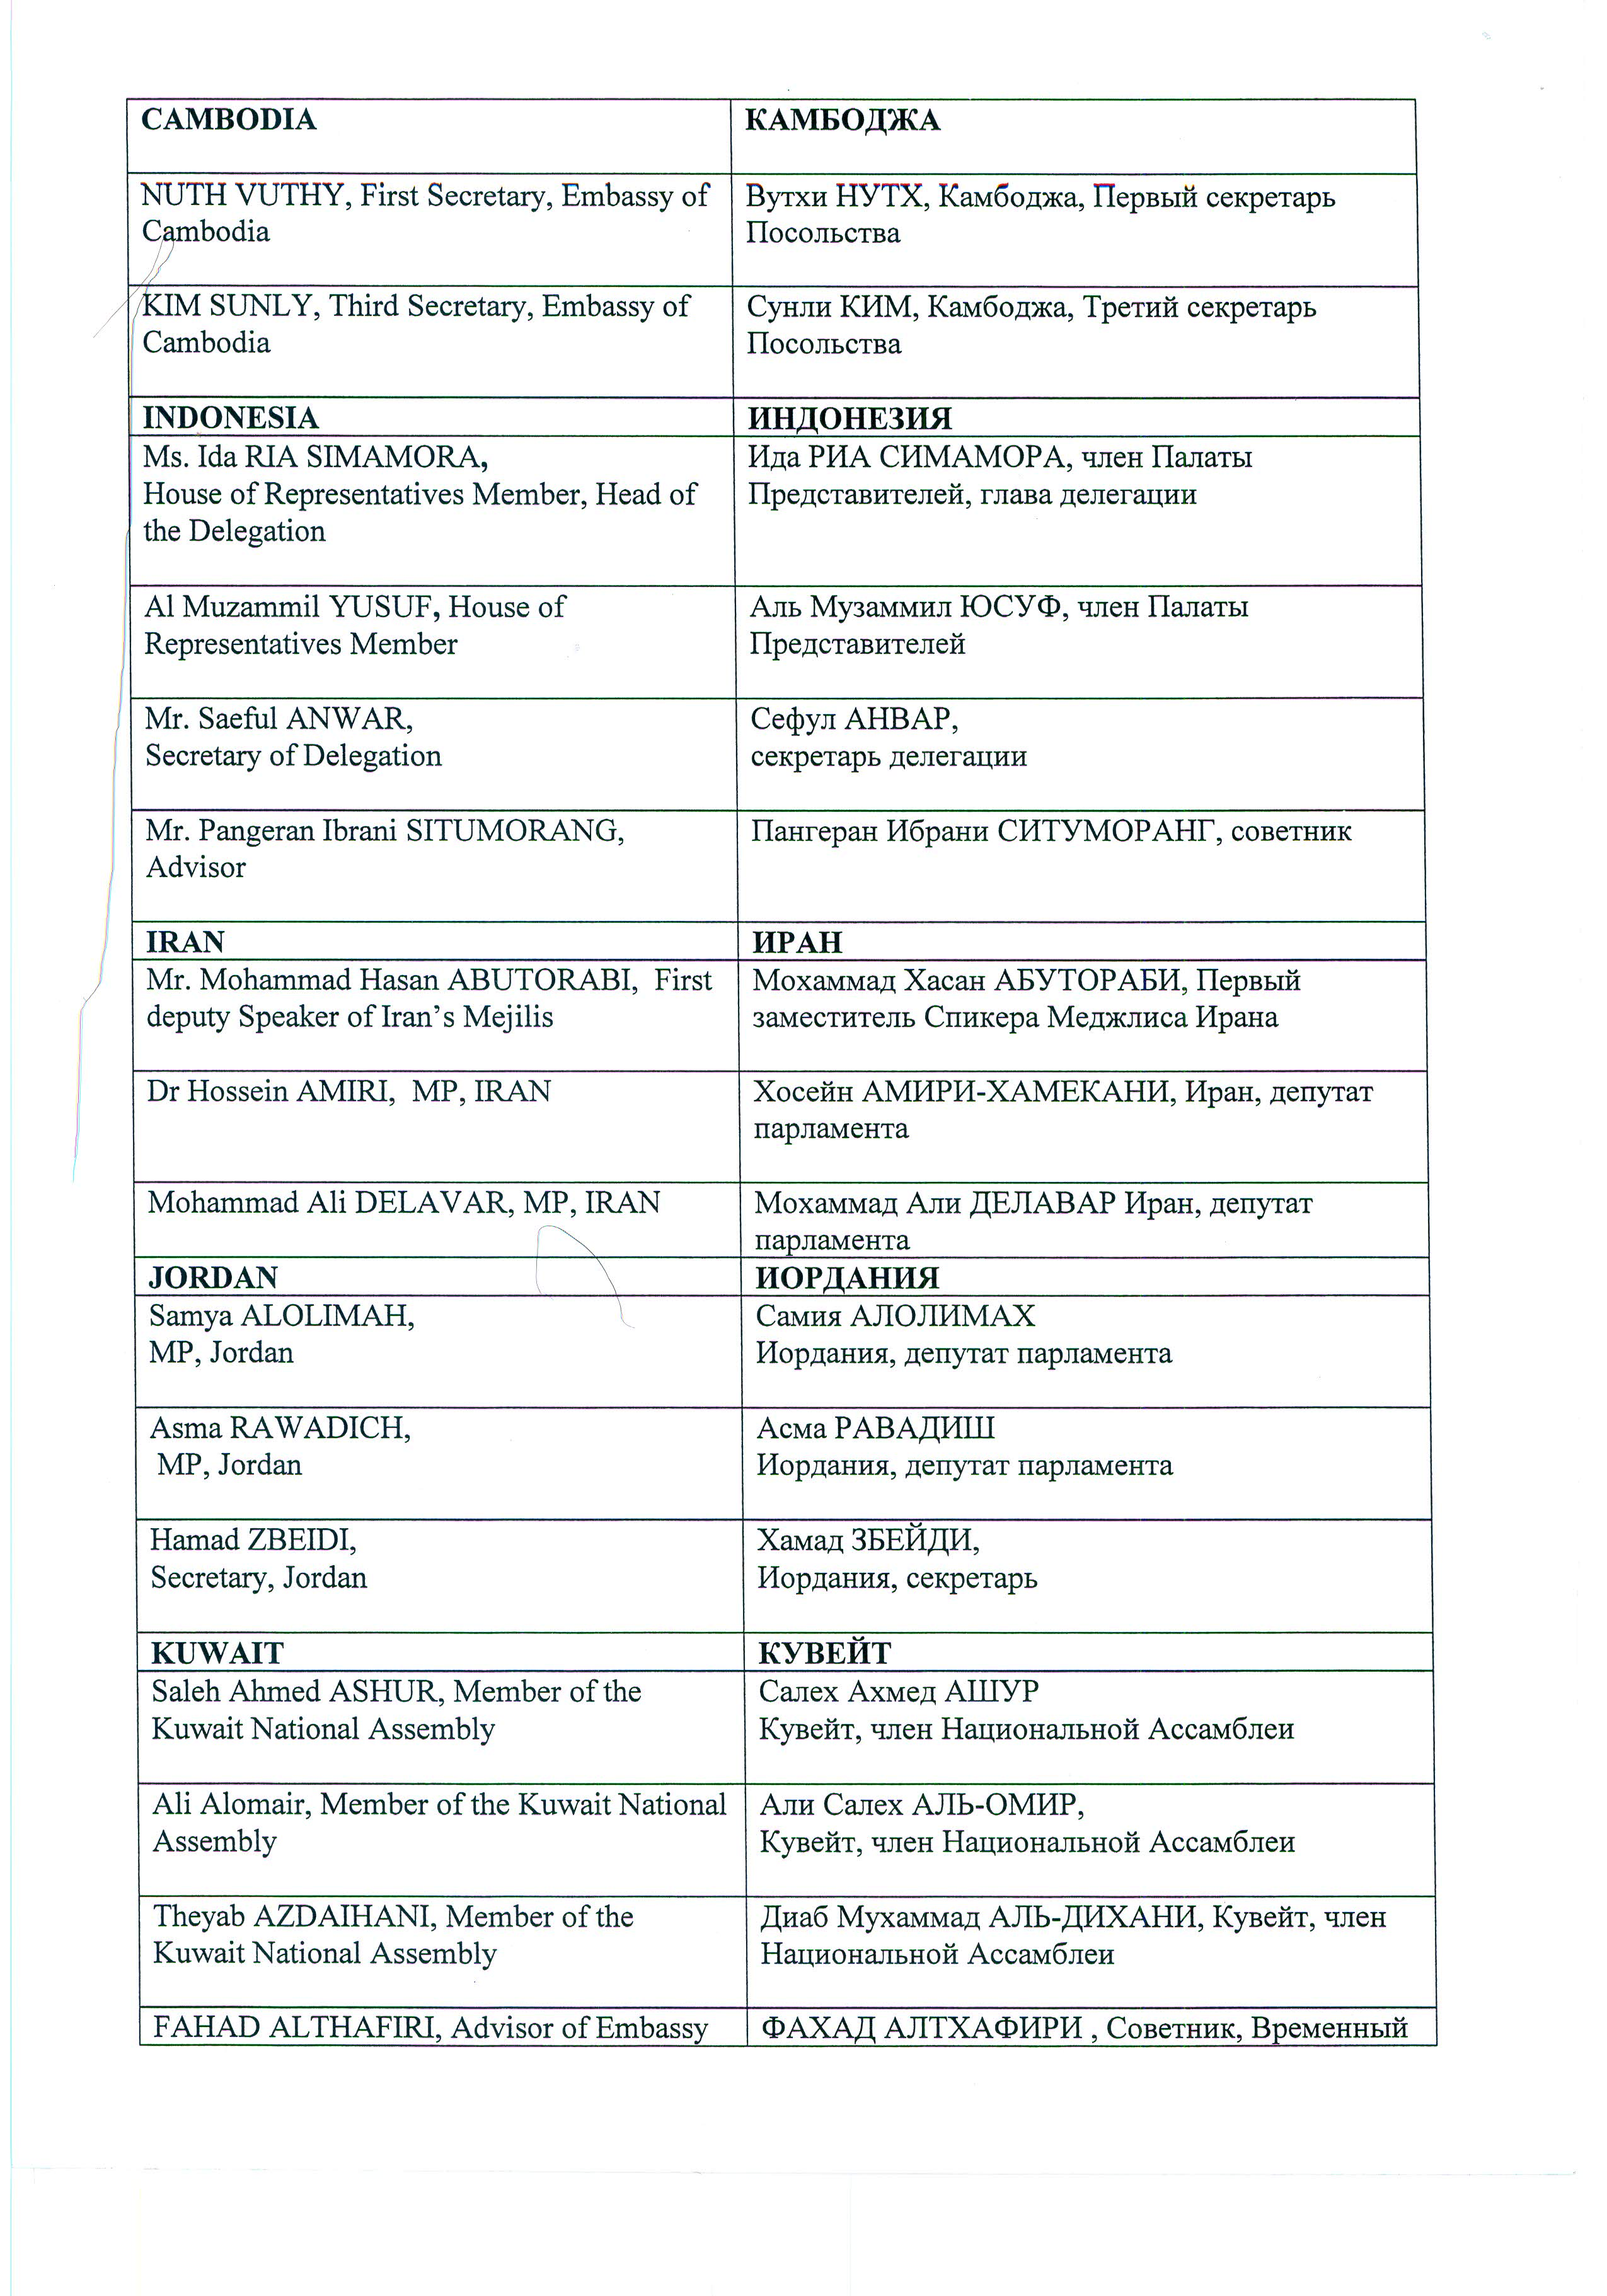
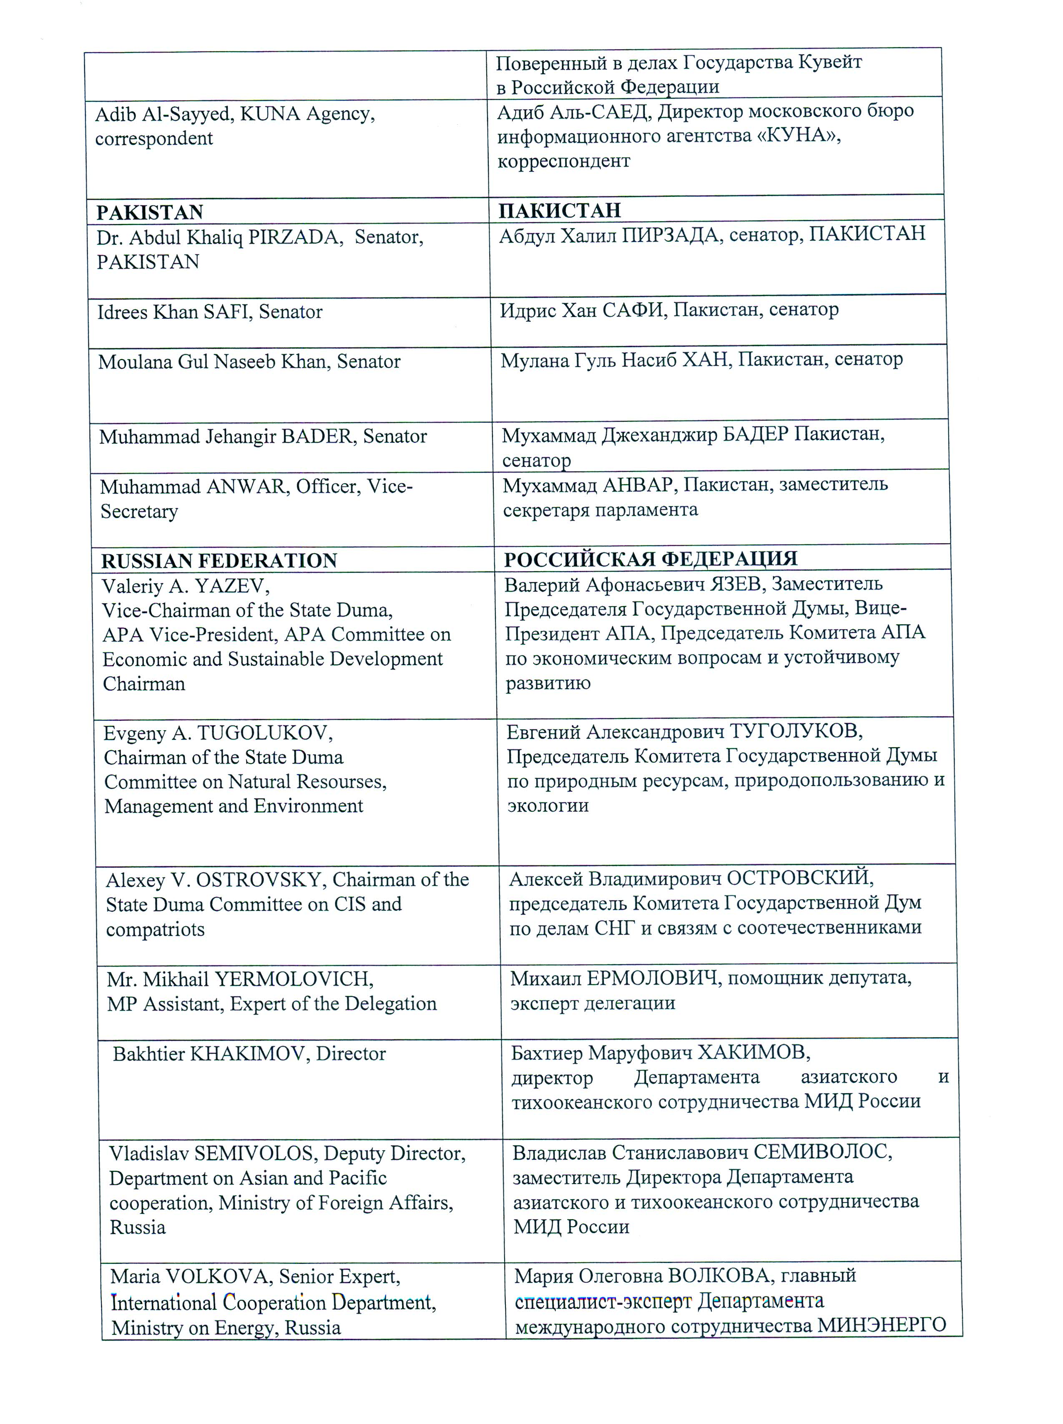
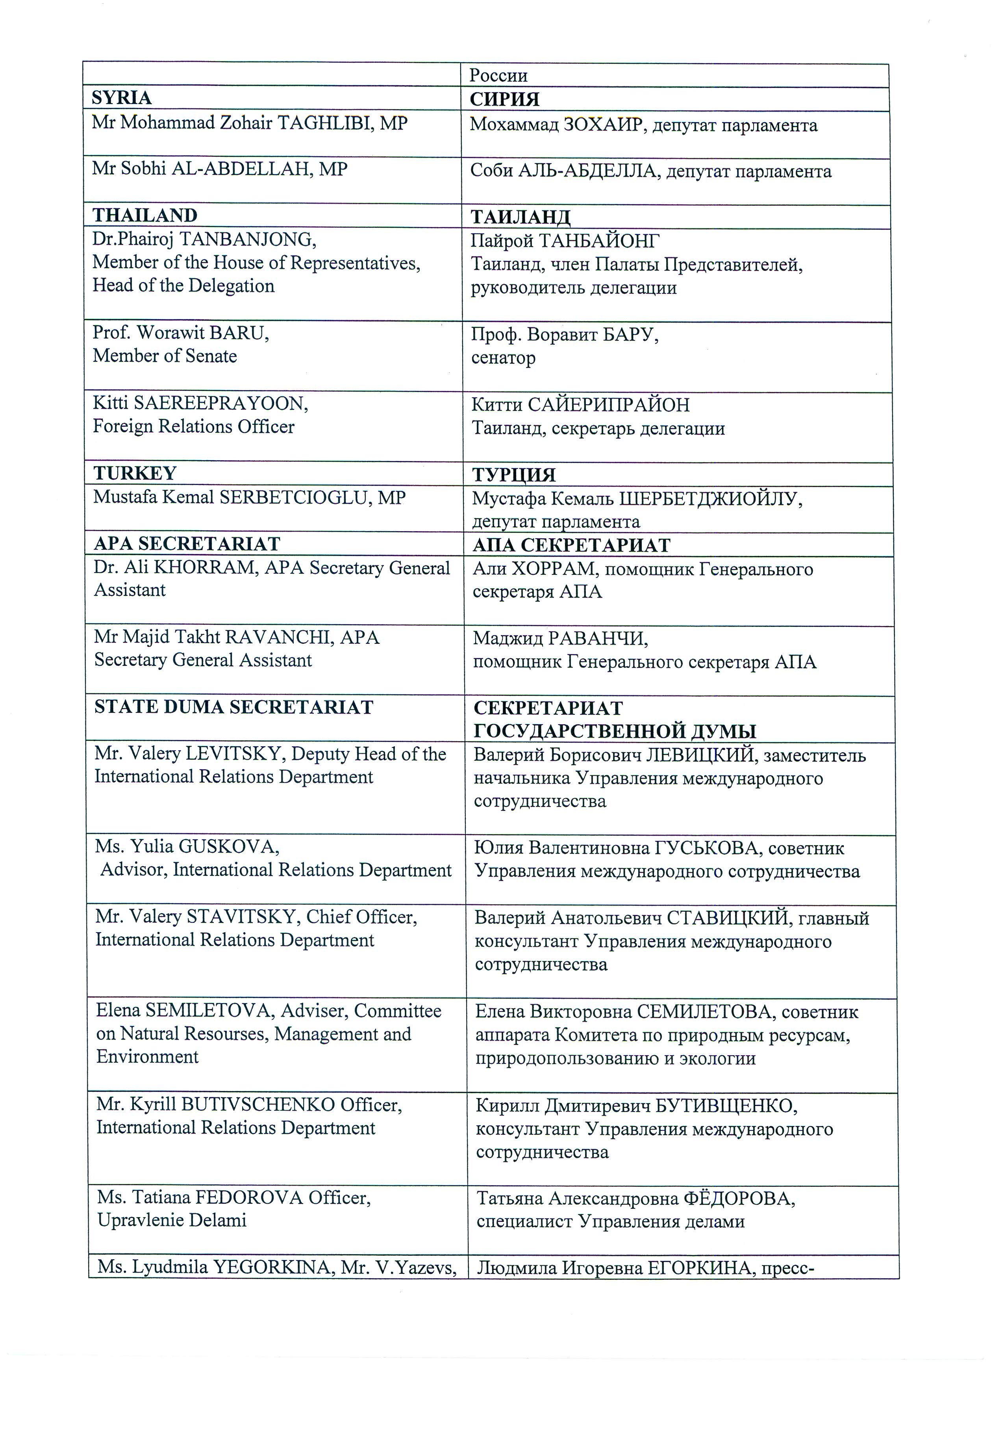
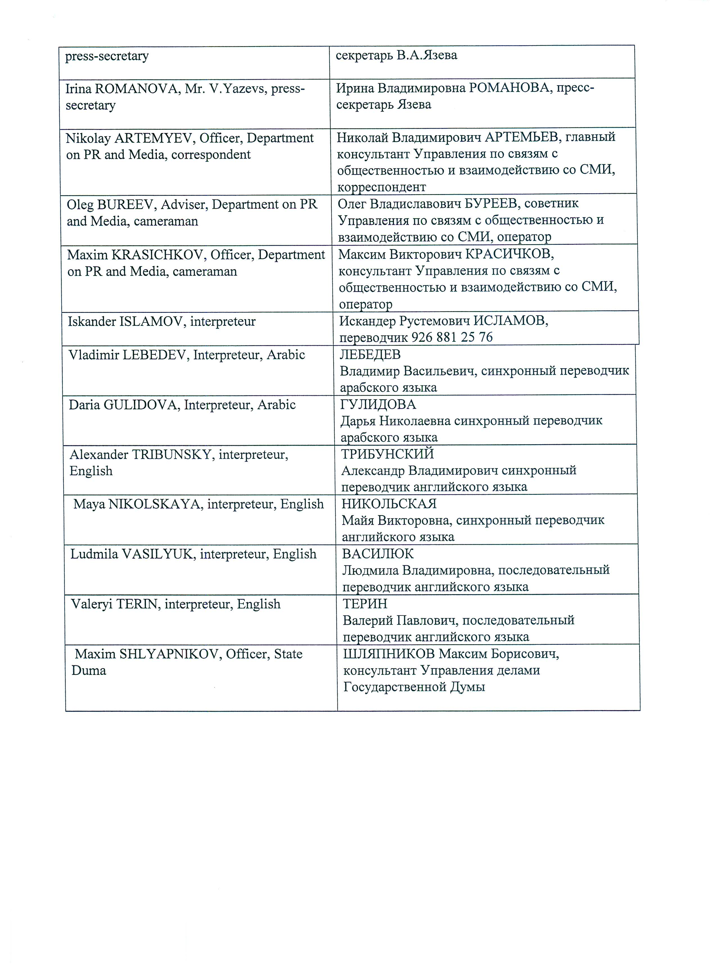
Annex - 3

SC/Economic/Res/2011/10
20 September 2011

Draft Resolution
on
Environmental Issues, Global Warming, Climate Change and
Planting Billions of Trees throughout Asia

We, the Members of the Asian Parliamentary Assembly,
Recalling the Resolution on Environmental Issues, Global Warming, Climate Change and Planting Billions of Trees throughout Asia, APA/Res/2010/13, dated 30 November2010;
Welcoming the Report of the Secretary-General on Environmental Issues, Global Warming, and Planting Billions of Trees throughout Asia, contained in document SG/Rep/2011/03-2 dated 3 September 2011;
Recognizing the need to pursue to the components of sustainable development namely the economic growth, social development and environmental protection in a balanced and mutually supportive manner;
Emphasizing the importance of realization of sustainable development objectives and the decisions of the 1992 Rio Conference bearing in mind the existence of different capacities and conditions of Asian countries;
Underlining the necessity of a comprehensive and long-term strategy to combat desertification, thus improving the living conditions of the people living in arid and semi-arid areas;
Recognizing the significance of exchanging information on environmental issues among Asian countries and transfer of environmental technology, in particular scientific and technical assistance, from those countries with high capabilities in the area of sustainable development to less developed countries in Asia;
Acknowledging the importance of enhancing the role of civil society, NGOs, policy think tanks, business and academia in the protection of environment through their inputs to the environmental policy formulation as well as implementation at the local, national and regional levels;
Noting with interest the findings of Intergovernmental Panel on Climate Change (IPCC) in its last report on forests: land use, land use change, and forestry (LULUCF), delivering an important message with possible indications for the APA’s goal of “Planting Billions of Trees throughout Asia”
Noting also with interest that LULUCIF is receiving increasingly positive attention in the context of Climate Change negotiations with noticeable levels of understanding and agreement to be further considered and finalized in the course of COP17 and COPMOP7 to be held in Durban-South Africa, late November 2011;
Recognizing the responsibility of developed countries and international institutions to meet the special needs of Asian countries, particularly Asian developing countries, in their efforts to deal with negative consequences of environmental degradation effectively and reiterating the importance of devising a proper mechanism for technology transfer and financing environmentally sound technology from developed to developing countries;
Emphasizing that substantive involvement of APA in the latest state of affairs as regards the ongoing negotiations within the context of UNFCCC and Kyoto Protocol, exchange of views among Member Parliaments and striving for bringing as much coordination and collaboration as possible in relevant negotiating fora with a view to serving and improving the common regional interest of the Asia is a compelling imperative;
Encouraging the inclusion of Asian parliamentarians in the national delegations participating in the climate change negotiations in Durban-South Africa;
Noting with satisfaction and expressing interest in the Cancún agreements including the “newly agreed financial and technological mechanisms” and its relevance and importance for Asia;
Emphasizing the importance of cooperation among Member Parliaments with regard to efforts to combat desertification;
1. Invite the Member Parliaments to proceed with legislation and other legal actions deemed appropriate and facilitative to encouraging the governments to formulate and implement legislations, policies and measures with regard to the following:
• Facilitating and encouraging the operationalization of the idea of “plantation of billions of trees” envisaged in APA documents, as an effective means of increasing afforestation and reforestation as well as strengthening the total GHG mitigation potential and finally contributing to reducing emissions from deforestation;
• Modal shifting from road to rail and inland waterway shipping, urban planning and non-motorized transport which offer opportunities for GHG mitigation, depending on local conditions and policies;
• Integrating climate policies in broader development policies with a view to making implementation and overcoming barriers easier;
• Financing and encouraging R&D for low carbon or cleaner technologies with a view to stimulating technological advances, reduce costs, and enable progress toward stabilization;
• Legalizing the necessity of observing the Environment Impact Assessment (EIA) as a step towards bringing a balance between the three pillars of sustainable development namely: economic growth, social development and environmental protection;
• Encouraging the maximum possible interaction, coordination, integrity and solidarity among Asian delegations involved in climate change negotiations with a view to providing for a collective wisdom by Asia as concerns their common interests which in turn shall strengthen Asian regionalism and contribute to the cause of an Asian integration;
• Interacting with and make collective attempts with other Asian States Parties for pushing the environmental priorities and urgencies of the Asia within the agenda of financial and technological mechanisms of environment related instruments such as GEF, those operating within UNEP and the newly established technological and financial mechanisms to be finalized in Durban late November and early December 2011;
2. Encourage the Asian parliaments to hold hearings, with the participation of governmental and non-governmental experts, on the Cancún agreements and possible outcomes of COP17 and COPMOP7 to be held in Durban to enable better preparations and coordination prior to the event;
3. Recommend the holding of APA coordination meetings of Member Parliaments in the sidelines of Durban event to enable the Members interact, assess the possibilities of better coordination and better understand the legislation challenges and opportunities as regards the draft agreements under negotiation and also as concerns the collective efforts with the APA;
4. Invite Member Parliaments to exchange experiences and best practices on environmental issues and provide, on a voluntary basis, the data concerning issues related to sustainable development, climate change and other environment related major issues to the Secretariat to be compiled in a database for the reference and use by all Member Parliaments;
5. Invite also Member Parliaments, in a position to do so, to provide material and technical support to APA members in their efforts to combat desertification;
6. Request the Secretary General to seek the views of Member Parliaments on the implementation of the present resolution and report thereon to the next session of the Sub-Committee in 2012.

SC/Economic/Res/2011/11
20 September 2011

Draft Resolution
on
Alleviating Poverty in Asia
We, the members of the Asian Parliamentary Assembly,
Recalling APA Resolution on Alleviating Poverty in Asia, APA/Res/2010/14, dated 30 November 2010;
Welcoming the report of the Secretary-General on Alleviating Poverty in Asia, SG/Rep/2011/03-1 dated 31 August 2011;
Taking note of the deliberations of the Sub-Committee on Alleviating Poverty in Asia;
Taking into consideration the actions APA member countries have taken in support of MDGs;
Underlining the significance of the role of Parliaments both in advocating and over sighting to achieve MDG 2015 Goals, especially Goal One on Poverty Eradication;
Recalling the High-level Plenary meeting of the sixty-fifth session of the U.N. General-Assembly on the Millennium Development Goals and its outcome;
Expressing great concern on the situation of the poor worldwide;
Reaffirming that each country must take primary responsibility for its own development and that the role of national policies and strategies cannot be overemphasized in the poverty eradication;
Noting that poverty alleviation is important to combat international terrorism, occupation, human and drug trafficking, arms smuggling and transnational crimes;
Stressing the significance of Official Development Assistance (ODA) to alleviate poverty in developing countries;
Encouraging the adoption of pro-poor economic growth policy;
Supporting the adoption of legislation on poverty alleviation programs including in urban areas;
Encouraging regional cooperation on poverty alleviation schemes;
Supporting the informal sector which plays an important role in poverty reduction and offering increased security to it;
Supporting also a publicity campaign to raise awareness in the society about MDG 1 goal utilizing the potentials of mass media particularly the radio and television;
1. Call on APA Member Parliaments to participate actively in the achievement of MDGs and urge Member Parliaments to encourage their governments to facilitate adoption of pro-poor economic growth policy;
2. Urge Member Parliaments to work closely with their governments in the formulation and implementation of the measures outlined in the High level Plenary meeting of the sixty-fifth session of the General-Assembly on the Millennium Development Goals;
3. Invite Member Parliaments to adopt necessary legislation to a) improve labor market regulations, b) support the informal sector and offering increased security to it, c) help to establish savings and loan associations in order to reduce the reliance on moneylenders, d) promote urban agriculture which contributes essentially to reduction of poverty in urban areas, e) empower the urban poor to improve their living conditions and participate in decision-making which affects their lives, f) help to upgrade the infrastructure and services in areas where the urban poor live and work and to provide better education for urban poor particularly for girls and g) improve disaster preparedness, disaster relief as well as post-disaster economic recovery;
4. Encourage Member Parliaments from developed countries to work closely with governments to facilitate in fulfilling all official development assistance commitments, including commitments made by many developed countries to achieve the target 0.7% of Gross National Product for ODA to developing countries as required by the Millennium Declaration;
5. Encourage further Member Parliaments to exchange views with parliaments of the countries of the region particularly neighboring countries on their best practices in the fight against extreme poverty and hunger;
6. Encourage also Member Parliaments to invite the representatives of the executive branch to the parliament to exchange views on the steps the government is taking towards reaching MDG 1;
7. Call on Member Parliaments to submit a report on their best practices and those of their executive branches to the APA Secretariat to be placed on the APA website;
8. Encourage Member Parliaments to take joint action to organize aid campaigns, on a voluntary basis upon the request of a Member Parliament, for assistance in the context of alleviating poverty;
9. Request the Secretary-General to seek the views of Member Parliaments on their efforts to implement this resolution and to submit a report thereon to the next meeting of the Sub-Committee in 2012.

S C/Economic/Res/2011/12
21 September, 2011

Draft Resolution
on
Integrated Energy Market in Asia

We, the Members of the Asian Parliamentary Assembly,

Recalling Resolution on the Asian Integrated Energy Market, APA/Res/2010/05, dated 16 June 2010; Resolution on the Asian Integrated Energy Market, APA/Res/2009/05, dated 11 December 2009; Resolution on the Asian Integrated Energy Market, APA/Res/2008/01, dated 29 November 2008; Resolution on the Asian Integrated Energy Market, APA/Res/2007/08, dated 19 November 2007; the Plan of Action on the promotion of an Integrated Energy Market in Asia, APA/Res/2007/08/Annex, dated 19 November 2007; and Resolution on Energy, APA/Energy Com/2007/01, dated 20 November 2007;
Welcoming the Report of the Secretary-General on the Asian Integrated Energy Market (AIEM), SG/Rep/2011/05, dated September 2011, to the meeting of the Energy Sub-Committee held in Moscow, Russia, on21September 2011;
Taking note of high rates of growth in energy demand in East Asia and the abundance of energy resources in West Asia as an important advantage in Asia which could facilitate steps towards the development of “Integrated Energy Market in Asia”;

Confirming the realization of the “Integrated Asian Energy Market” when the Asian Parliamentary Assembly envisages a continental energy supply system in Asia;

Recognizing that “Integrated Asian Energy Market” can help the Asian countries to maximize the interests of both producers and consumers and minimize the risks and costs of energy in Asia;

Emphasizing the rights of any country to have any kind of energy including nuclear energy for peaceful use;

Reaffirming the importance of adoption and implementation of environmentally sound energy policies and projects throughout Asia;

Welcoming the decreasing trend of energy intensity in the most regions of the world and in particular in Asia;

Recognizing that any improvement in energy efficiency is expected to have significant effect on mitigating the environmental impact of the use of fossil fuels;

Welcoming the Asian governments’ commitments to reduce carbon emissions affecting global warming;

Emphasizing again on the imperative of “Stability of Global Energy Market”, including rationalization of demand and maximization of energy production;

Encouraging joint investments in energy-related industries among the energy-producing Member States;

Emphasizing on multilateral co-operation among APA countries in order to improve energy transportation infrastructures in Asia;
Appreciating the State Dumas of Russia as the candidate for hosting the International Conference on Integrated Energy Market in Asia to be held in 2012

We, therefore;

- Urge all nations including APA countries to arrange for plans to increase their energy efficiency and decrease their energy intensityaccordingly;

- Urge again Member Parliaments to report to the Secretary-General on their national experiences in the field of increasing energy efficiency as outlined in Paragraph 33 of the Secretary-General’s Report contained in SG/Rep/2008/01/Rev.1 dated 10 May 2008;

- Urge also Asian Parliaments to encourage and support research programs, through comprehensive energy legislation, for energy efficiency, including in the field of renewable and carbon and methane capture and sequestration technologies, preferably with provisions for specific targets and timelines;

- Request the Secretary-General, in collaboration with the State Duma of Russia, to hold the International Conference on Integrated Energy Market in Asia not later than June 2012 in order to develop the views and the outcome of the Conference far enough before the next Sub-Committee meeting;

- Confirm the essential role of APA Member Parliaments to promote strategies for Asia-wide energy policy development bearing in mind their desire to hold the afore-mentioned International Conference;

- Request the Secretary-General as well as the State Duma of Russia to provide a joint report of the International Conference to the Sub-Committee and give advice in terms of identifying the priority areas which are going to be recognized by the International Conference and suitable to be pursued for the implementation of objectives delineated in the APA Energy Plan of Action, including that on Promotion of Integrated Energy Market in Asia and expect all other Member Parliaments to join the Conference and play active role in developing their views and goals;

- Request also the Secretary-General to seek the views of Member Parliaments on the implementation of this resolution and to report thereon to the next meeting of the Sub-Committee;
- Decide to extend the mandate of the Sub-Committee to promote the development of the Asian Integrated Energy Market.

SC/Economic/Res/2011/13
21 September 2011

Draft Resolution
on
Ramification of International Financial Crisis for the
Economies of the Countries of APA Member Parliaments
Moscow, Russia

We, the Members of the Asian Parliamentary Assembly,

- Recalling Resolution on the Ramification of International Financial Crisis for the Economies of the Countries of APA Member Parliaments, APA/ Res/2010/06 dated 10 December 2010, Resolution APA/Res/2009/05dated 11 December 2009; and Resolution APA/Res/2008/05dated 29 November 2008;
- Gravely concerned about the failure of the European Union and the United States to address the risks associated with their policies which could cause the global economy enter again into a double-dip recession;

- Expressing concern about the lack of re-orientation of policies needed for rebalancing on the agenda of the major economies at large;

- Expressing concern also about an early withdrawal of monetary and stimulus measures by the Western countries which may cause more serious challenges in the global economy in the coming years than they have seen during the 2007-2009 global downturn;

- Re-Affirming further concern about the disconnection between the financial markets and the real economy which threatens creating new bubbles in the world economy;

- Recognizing the necessity to effectively reform the global financial architecture so
as to achieve a more balanced world economic and financial order;

- Expressing real concern about the continuous negative repercussions of the ongoing Western Financial Crisis on the economies of the APA countries;

- Gravely concerned about the new international economic recession which can have devastating consequences on APA economies;

- Reaffirming the important role that the APA family can play through new legislations in managing and preventing further expansion of the new financial crisis;

- Expressing concern about the decrease in the investments of multilateral financial institutions in the Asian countries, which, in turn, can leave negative impact on their productive capacity, employment, export, and foreign exchange potentials;

- Supporting the deliberations at the UN, IMF, WTO, WB, and other international fora and their recommendations towards ameliorating the Western financial crisis and redressing the situation;

- Appreciating the measures that have already been taken by Asian Parliaments and their governments to contain the negative impact of the 2007-2009 crisis on their economies, and expecting them to take further steps to stimulate their respective economies;
We, therefore;
- Callupon the Asian Parliaments to continue and extend the stimulus measures to
prevent the probable financial sector fallout;

- Urge the Asian countries to take into serious account the risk which is coming from the widening global macroeconomic imbalances and may cause a new wave of financial instability in Asia;

- Urge Asian Parliaments to re-examine the efficiency of the framework of national regulatory bodies, with a view to preventing new instability in Asian markets;

- Urge Asian Parliaments to collectively address the incoming crisis including the establishment of a recent global financial architecture and its elements;

- Urge APAMember Parliaments to make major contributions to maintaining the stability of international economic and trade activities through preserving the global peace and security;

- Decide to promote respect for the international agreed laws and standards by APA Parliaments on the transparency of financial markets to ensure the clarity of financial transactions;

- Call upon the Secretary-General to realize the Panel of Experts through holding the incoming International Conference to conduct a comprehensive study and offer independent advice to the Sub-Committee on issues that they shall deem relevant to the whole trend of new Global Financial Crisis and its impacts on the APA economies;

- Call upon the Asian Parliaments to closely examine the economies of several Developing and Emerging Economies (DEEs) in Asia that have structural external deficits and are hence dependent on capital inflows to sustain acceptable growth;

- Call for adjustment in the major economies of Asia with the aim of removing imbalances while ensuring adequate global demand without a return to financial bubbles and debt–driven spending;
- Decide to rename the Sub-Committee as "Sub-Committee on Improvement of the Global Financial System";

- Call for close cooperation and coordination between Asian governments and Parliaments to control the persisting negative consequences of the incoming financial crisis on Asian economies; and

- Decide on the extension of the mandate of the Sub-Committee to review the development of the incoming financial crisis and to propose ways to control, manage and formulate exit strategy from the probable global crisis.

